PRELUDE (let us quiet our hearts before the Lord)
Welcome to BUMC! Our church family is delighted that you have joined us to worship today! We pray that you will be blessed by our worship service. We invite those who are not members to consider membership. Please speak with the Pastor or Lay Leader.

CALL TO WORSHIP
L: As we gather to worship today, turn to a neighbor and say to each other, “Welcome! I am glad that you are here!”.
P: Welcome! I am glad that you are here!
L: Now turn to another neighbor and say to each other, “You are loved by God and by me!”
P: You are loved by God and by me!
L: Beloved children of God, how can we love each other today?
P: By meeting and listening and caring for one another face-to-face.
L: Beloved children of God, how can we love each other today?
P: By practicing our love for one another and God with all our heart, soul, mind, and strength.
L: Let us worship God together today!
ALL: We come to worship God by living our love for God and neighbor face-to-face. Amen.
OPENING HYMN “All Hail the Power of Jesus’ Name” UMH 155

PASTORAL PRAYER

OPENING PRAYER (in unison): Almighty and everlasting God, increase in us the gifts of faith, hope, and charity; and, that we may obtain what you promise, make us love what you command; through Jesus Christ our Lord, who lives and reigns with you and the Holy Spirit, one God, forever and ever. Amen.

WELCOME & GREETINGS

PSALTER Psalm 90: 1-6, 13-17 UMH 809
1st READING Deuteronomy 34: 1-12
L: This is the Word of God
P: For the People of God

SHARINGS, JOYS, CONCERNS, PRAYERS OF THE PEOPLE

PRAYER OF CONFESSION (in unison): Lord, you have told us what to do. But this love thing is hard. You’ve invited us to love you with everything we have; instead, we have fallen in love with our jobs, houses, and electronic toys. Loving you intimately is scary, and we often opt for another way. You’ve invited us to live in loving relationship with everyone we encounter, but there are folk who are downright hard to love. We confess our inability to love as we should. We need your forgiveness and help living out this love thing. Free us to love as you do. Amen.

WORDS OF ASSURANCE

MUSICAL INTERLUDE

GOSPEL READING Matthew 22: 34-46
L: This is the Gospel of the Lord
P: Praise to You Lord Jesus Christ

PRAISE AND WORSHIP
“Blessed Be the Name of the Lord” TFWS 2034
“Jesus, Name Above All Names” TFWS 2071

SERMONIC HYMN “Jesu, Jesu” UMH 432

SERMON Pastor Egan Bovell
PRAYER OF DISCIPLESHIP

TITHES AND OFFERING

DOXOLOGY UMH 95
NOTICES & ANNOUNCEMENTS

CLOSING HYMN “More Love to Thee, O Christ “ UMH 453

BENEDICTION

***************************************************************************
Our Mission Statement

The Bloomfield United Methodist Church’s mission is to be an instrument of God’s purpose in the world by coming together as a Christian faith community which is open to all ages and races; promoting spiritual growth and Christian ideals in daily living; providing opportunity for worship; nurturing and caring for one another; educating our children so they will know God; and reaching out to, and welcoming in the community and the world.

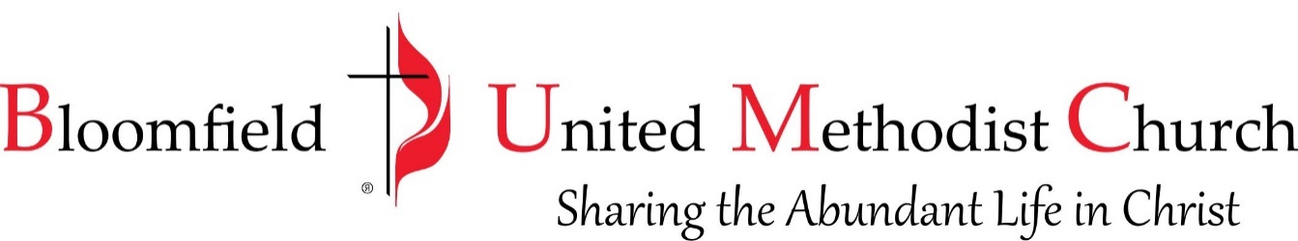

22nd Sunday after Pentecost
October 29, 2023
11:00am
