LIGHTING OF THE CHRIST CANDLE

PRELUDE

CALL TO WORSHIP
L: This is a new day! A day of marvels and miracles! A day to rejoice in what God has done! Yesterday was filled with too many worries and too little faith.
P: On this Easter morning, we hear the old folks saying “Mary, don’t you weep”.
L: The tomb is dark, but empty.
P: The one you are looking for has overcome the darkness.
L: The stone has been rolled away.
P: The one you are looking for has overcome death!
L: The burial clothes are put aside.
P: The one you are looking for is alive!
L: Christ is Risen!
P: Christ is Risen Indeed!
ALL: Let us worship our Risen Savior! Amen.

OPENING HYMN “Up From the Grave He Arose” UMH 322
accompanied by the BUMC Youth Bell Choir
OPENING PRAYER: O God of all our days, we come this morning with eager anticipation. We seek to know you, to see you, to touch you. Open our hearts, that we might experience you anew. Open our lives, that we may be faithful witnesses
to your resurrection. May we, with shouts of joy, proclaim your steadfast, liberating love to all people everywhere O God. Bless us this morning with resurrection rampage. A rampage that summons us to shout yes to the birth of new creation in our midst. May we experience the birth quakes of new life in our lives and in our congregation. The Son is up! And we are up with the Son, despite all those things that seek to pull us down to despair. We are your Easter People. Amen.

WELCOME & GREETINGS

PSALTER Psalm 118:14-24 UMH 839

“Sin Box” BUMC Children & Youth

1st READING Acts 10: 34-43

TIME WITH THE CHILDREN

SHARINGS, JOYS, CONCERNS & PRAYERS OF THE PEOPLE

MUSIC MINISTRY BUMC Youth Bell Choir

GOSPEL READING Mark 16: 1-8

HYMN “He Lives” UMH 310

SERMON Pastor Egan Bovell

PRAYER OF DISCIPLESHIP

MUSIC MINISTRY “Because He Lives” Katana Tate

HOLY COMMUNION

TITHES & OFFERINGS UMH 95

NOTICES & ANNOUNCEMENTS

EASTER LILY ACKNOWLEDGEMENTS

CLOSING HYMN “He Rose” UMH 316

POSTLUDE “Hallelujah Chorus”
(please remain seated)
PRAYER LINE – Tuesdays at 6:30am
Phone #: 848 220 3300 / Conference ID #: 5203248

ZOOM BIBLE STUDY – Wednesdays at 7:00pm
Meeting ID: 873 3085 4771 / Passcode: 810341

SAVE THE DATE!
The Bloomfield Strawberry Festival will be on Saturday, June 29, 2024 from 12:00pm – 7:00pm. Vending application at www.bumcct.org.

PRAYER LIST: Brenda Ifill, Cheryl Pringle, Ron Dixon, Carmen Edith Morris, Billie & Michael Anthony, Liz Donar, Rev. Boliver Valentine, Audrey Nathan, Avril Wallace, Anthony and I-rose Gordon, Molly Williams, Leroy Clemons, Roy Greaves, Demery family, Robert Brown, Ted Baron, Boris, the families of Margaret Leslie, Derek Bruce, Norma Murphy and all those experiencing the loss of loved ones.

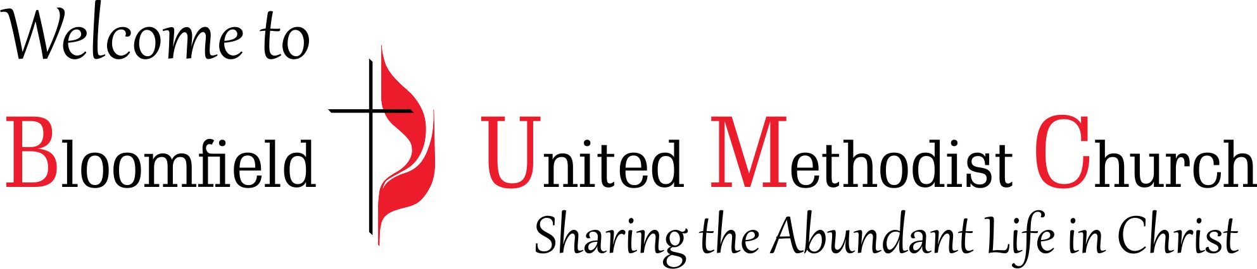

Easter Sunday

March 31, 2024
11:00am

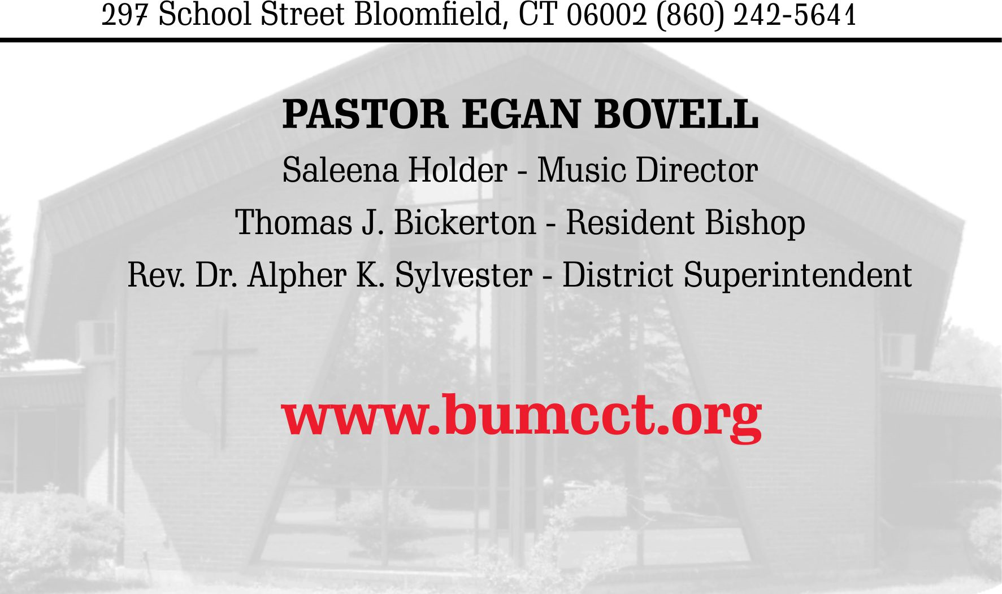
EASTER LILY ACKNOWLEDGEMENTS

Avril Wallace
- In memory of Wise Blake (from your loving sweetheart)
- In memory of Albert & Eva Wallace (parents)
- In memory of Denny Tate (from your loving mother)
Barbara Holder & Saleena Holder
- In memory of Arthur Hinds
- In memory of all those loved and lost
Cecilia Springer
- In memory of Rita Springer
Jacqueline Springer
- In memory of Dorothy Springer
Joy Holder
- In memory of Vera Holder
Marlene Dacosta
- In memory of Isaiah DaCosta
- In memory of Dorothy DaCosta
Orlene Green
- In memory of Clinton Scarlett
- In honor of Abel Counseling, LLC, Community Counseling
Stella Springer
- In memory of Maureen Miller
Valda Lawrence
- In memory of Joyce Parks (sister)

EASTER LILY ACKNOWLEDGEMENTS

Avril Wallace
- In memory of Wise Blake (from your loving sweetheart)
- In memory of Albert & Eva Wallace (parents)
- In memory of Denny Tate (from your loving mother)
Barbara Holder & Saleena Holder
- In memory of Arthur Hinds
- In memory of all those loved and lost
Cecilia Springer
- In memory of Rita Springer
Jacqueline Springer
- In memory of Dorothy Springer
Joy Holder
- In memory of Vera Holder
Marlene Dacosta
- In memory of Isaiah DaCosta
- In memory of Dorothy DaCosta
Orlene Green
- In memory of Clinton Scarlett
- In honor of Abel Counseling, LLC, Community Counseling
Stella Springer
- In memory of Maureen Miller
Valda Lawrence
- In memory of Joyce Parks (sister)

