LIGHTING OF THE CHRIST CANDLE

PRELUDE

CALL TO WORSHIP
L: This day is the Lord’s, created for joy.
P: Let us rejoice and be glad in it!
L: Hosanna to Christ, the blessed child of God.
P: Hosanna to God in the highest!
L: Blessed is the one who comes in God’s name.
P: Hosanna to God in the highest!
L: This day is the Lord’s, created for love.
ALL: Let us rejoice and be glad in it! Amen.

OPENING HYMN “Hosanna, Loud Hosanna” UMH 278

PASTORAL PRAYER

OPENING PRAYER: God of grace and glory blessed is your Son, Christ Jesus, and blessed is your holy name. As we bless your name and sing with joy, awaken our ears to hear your word; awaken our hearts to listen for your wisdom. As we rejoice in this day that you have made, help us hear even the hard news of Christ’s suffering and death. As we celebrate your presence with palms and praises, guide us to live your teachings, even when the path is painful and difficult. May your presence flow through us into your world. In the name of your Son, Christ Jesus, we pray. Amen.

WELCOME & GREETINGS
PSALTER Psalm 118 UMH 839

OT READING Isaiah 50: 4-9a

2nd READING Philippians 2: 5-11

PRAYER OF CONFESSION Insert

SHARINGS, JOYS, CONCERNS & PRAYERS FOR THE WORLD

MUSIC MINISTRY BUMC Youth Bell Choir

GOSPEL READING Mark 11: 1-11

PRAISE & WORSHIP
“Praise the Name of Jesus” TFWS 2066
“Jesus Walked This Lonesome Valley” TFWS 2112
“He Touched Me” UMH 286

SERMON Pastor Egan Bovell

PRAYER OF DISCIPLESHIP

BLESSING & DISTRIBUTION OF PALMS

TITHES & OFFERINGS

DOXOLOGY UMH 95

NOTICES AND ANNOUNCEMENTS

CLOSING HYMN “When I Survey The Wondrous Cross”
UMH 298

BENEDICTION
PRAYER LINE – Tuesdays at 6:30am
Phone #: 848 220 3300 / Conference ID #: 5203248

ZOOM BIBLE STUDY – Wednesdays at 7:00pm
Meeting ID: 873 3085 4771 / Passcode: 810341

Purchase an Easter lily in honor or in memory of someone. The lilies will be placed on the altar for Easter Sunday. Each lily is $15. See Saleena.

UPCOMING SERVICES/ACTIVITIES:
Good Friday Service – March 29, 2024 at 5pm
Children & Youth Easter Celebration – Saturday, March 30, 2024 at 4pm
Easter Sunday Service – March 31, 2024 at 11:00am

North UMC Good Friday Service will be on March 29, 2024 at 12:00pm.

PRAYER LIST: Brenda Ifill, Cheryl Pringle, Ron Dixon, Carmen Edith Morris, Billie & Michael Anthony, Liz Donar, Rev. Boliver Valentine, Audrey Nathan, Avril Wallace, Anthony and I-rose Gordon, Molly Williams, Leroy Clemons, Roy Greaves, Demery family, Robert Brown, Ted Baron, Boris, the families of Margaret Leslie, Derek Bruce, Norma Murphy and all those experiencing the loss of loved ones.

Passion/Palm Sunday
March 24, 2024
11:00am

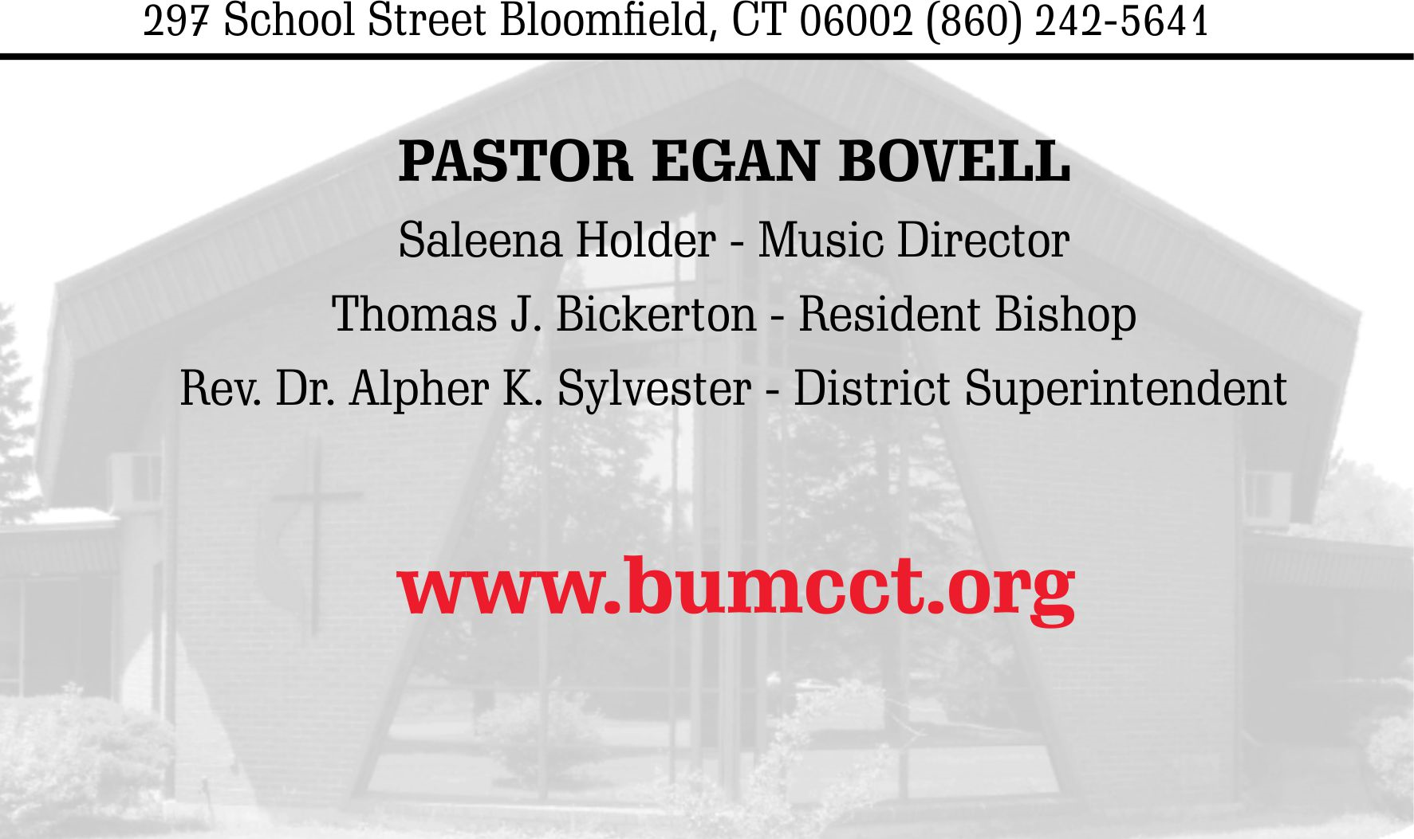
PRAYER OF CONFESSION

L: Six days before the Passover, Jesus came to the home of
Lazarus and received hospitality like no one had seen before
generous, loving, whole-hearted, and even a little bit undignified. His disciple Judas could only see the inefficiency
of the gift, not the spirit of loving-kindness with which it was
offered. We, like Judas, often want to expedite our giving
without really engaging with those we are called to serve.
Let us consider the depth of our relationships with those we
encounter and with the One who calls us to faith, as we confess our sin in silence. (all pause for silence)

ALL: We confess, Anointed One, that we excuse ourselves from reaching out to those who need your care. We take your words – that there will always be unmet needs – as a reason not to try to meet the needs we can. Forgive us and help us to change. Renew our determination to live as faithful followers, faithful disciples, faithful Christians.
Help us to work with you for the well-being of your creation, that the fortunes of all your peoples may be restored. Amen.

PRAYER OF CONFESSION

L: Six days before the Passover, Jesus came to the home of
Lazarus and received hospitality like no one had seen before
generous, loving, whole-hearted, and even a little bit undignified. His disciple Judas could only see the inefficiency
of the gift, not the spirit of loving-kindness with which it was
offered. We, like Judas, often want to expedite our giving
without really engaging with those we are called to serve.
Let us consider the depth of our relationships with those we
encounter and with the One who calls us to faith, as we confess our sin in silence. (all pause for silence)

ALL: We confess, Anointed One, that we excuse ourselves from reaching out to those who need your care. We take your words – that there will always be unmet needs – as a reason not to try to meet the needs we can. Forgive us and help us to change. Renew our determination to live as faithful followers, faithful disciples, faithful Christians.
Help us to work with you for the well-being of your creation, that the fortunes of all your peoples may be restored. Amen.

