LIGHTING OF THE CHRIST CANDLE

PRELUDE

CALL TO WORSHIP
L: Lenten travelers, how long have you traveled this road with your gaze pointed down at the dust and gravel and asphalt as you walk or limp or roll down the path? P: Sometimes it is easier to look at the road than at the people who share the journey with us. L: Lift up your heads! Look, listen, reach out a hand. Who are your neighbors on this road? P: We lift our heads and look to our Savior who journeys with us and helps us notice our neighbors all around us. L: This is the Lenten journey—to learn to love God and love our neighbors just as Jesus showed us. P: Our journey teaches us to lose our lives to God as we find and follow Christ in our service to others. L: Come, let us worship God who caravans with us on this road to the cross.
P: Come, let us worship! Amen.

OPENING HYMN “Take Up Thy Cross” UMH 415

PASTORAL PRAYER

OPENING PRAYER: Lord, we know Easter is coming soon and while we anxiously wait to celebrate your triumphant victory over sin and death, there are still difficult days between now and then. And try as we might, we cannot comprehend love and mercy so great as this. There is nothing perfect about us, yet you beckon us with hands that soon will be scarred by betrayal, greed, selfishness, pettiness, pride, and apathy. You see us and our imperfections with compassionate and patient eyes as we struggle to rid our lives of all the worldly things that distort, distract, and entangle us. As the cross looms ahead, our eyes and our focus are on you and you alone for our redemption and salvation. Amen.

WELCOME & GREETINGS

PSALTER Psalm 51: 1-12 sung response UMH 785

1st READING Jeremiah 31: 31-34

SHARINGS, JOYS, CONCERNS & PRAYERS FOR THE WORLD

RECEPTION INTO LOCAL CONGREGRATION

MUSICAL INTERLUDE

GOSPEL READING John 12: 20-33

SERMONIC SONG ‘Glorify Thy Name” TFWS 2016

SERMON Pastor Egan Bovell

PRAYER OF DISCIPLESHIP

TITHES & OFFERINGS

DOXOLOGY UMH 95

NOTICES AND ANNOUNCEMENTS

CLOSING HYMN “Where He Leads Me” UMH 338

BENEDICTION
PRAYER LINE – Tuesdays at 6:30am
Phone #: 848 220 3300 / Conference ID #: 5203248

ZOOM BIBLE STUDY – Wednesdays at 7:00pm
Meeting ID: 873 3085 4771 / Passcode: 810341

UPCOMING SERVICES/ACTIVITIES:
Palm Sunday Service – March 24, 2024 at 11am
Good Friday Service – March 29, 2024 at 5pm
Children & Youth Easter Celebration – Saturday, March 30, 2024 at 4pm
Easter Sunday Service – March 31, 2024 at 11:00am

PRAYER LIST: Brenda Ifill, Cheryl Pringle, Ron Dixon, Carmen Edith Morris, Billie & Michael Anthony, Liz Donar, Rev. Boliver Valentine, Audrey Nathan, Avril Wallace, Anthony and I-rose Gordon, Molly Williams, Leroy Clemons, Roy Greaves, Demery family, Robert Brown, Ted Baron, Boris, the families of Margaret Leslie, Derek Bruce, Norma Murphy and all those experiencing the loss of loved ones.

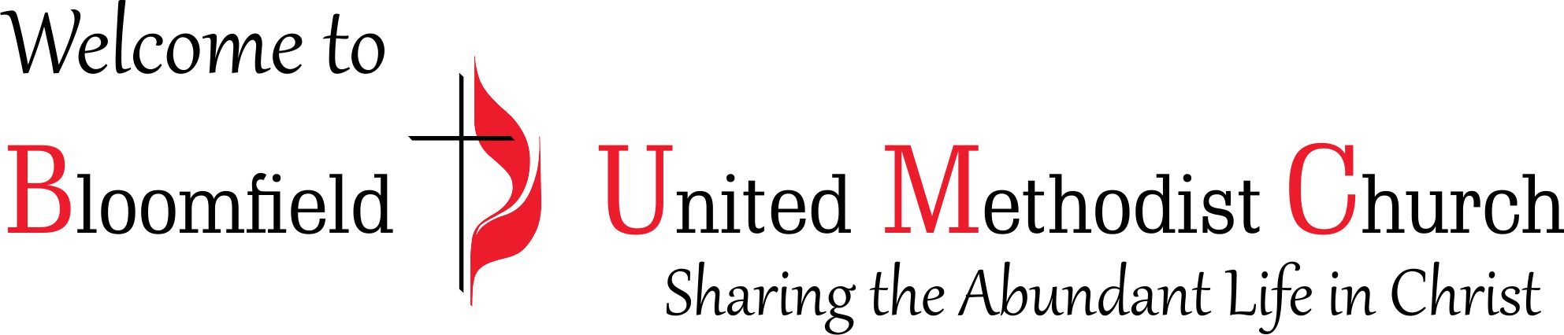

5th Sunday in Lent

March 17, 2024
11:00am

