CALL TO WORSHIP
L: Christ is calling you as disciples
P: Lord Jesus, let us follow you faithfully.
L: You will be led into fields of mission and service.
P: Lord Jesus, where you lead us, we will go.
L: Listen for Christ’s call to you.
P: We are ready to serve the Lord. Amen.

OPENING HYMN “Guide Me, O Thou Great Jehovah” UMH 127

PASTORAL PRAYER

OPENING PRAYER: Open our hearts and spirits this day to hear the great good news of your power and presence with all your people. Fill our hearts with rejoicing as the words are proclaimed in song and story. Enliven us and remind us that you are with us, through the pillar of fire, through the magnificent words of the prophets, through the ministry and love of Jesus Christ. Amen.

WELCOME AND GREETINGS

PSALTER Psalm 111 UMH 832

THE GLORIA PATRI UMH 71

PRAYER OF CONFESSION: We think we know so much, O God, and with our meager knowledge we presume to judge others. We arrogantly announce our own righteousness without compassionate thought. We proclaim your word when it suits us and often only to those with whom we want to associate. We shut others out because of our faulty judgment and our blindness. There have been so many times in which our humble help would have been a blessing to someone, but we have placed our comforts before serving others. In the competing voices of today’s world, we have turned around and around, trying to find the way to live. Help us, merciful God, to again listen to you. Help us to truly open our hearts to you. Remind us again of your great love and presence in our lives. Forgive us our foolishness and our stubbornness. Create in us new spirits, filled with your love, offering peace and hope to all. In Jesus’ Name we pray. Amen.

1st READING Deuteronomy 18: 15-20

SHARINGS, JOYS, CONCERNS & PRAYER OF THE PEOPLE
MUSICAL INTERLUDE

2ND READING 1 Corinthians 8: 1-13

TIME WITH THE CHILDREN

GOSPEL READING Mark 1: 21-28

PRAISE AND WORSHIP
“Blessed be the Name” TFWS 2034
“More Precious than Silver TFWS 2065
“Through it All” UMH 507

SERMON Pastor Egan Bovell

PRAYER OF DISCIPLESHIP

TITHES AND OFFERINGS

OFFERTORY PRAYER

NOTICES & ANNOUNCEMENT

CLOSING HYMN “Close to Thee” UMH 407

BENEDICTION

PRAYER LINE – Tuesdays at 6:30am
Phone #: 848 220 3300 / Conference ID #: 5203248

ZOOM BIBLE STUDY – Wednesdays at 7:00pm
Meeting ID: 873 3085 4771 / Passcode: 810341

The Cooperative Parish Black History Month Service will be on Sunday, February 18, 2024 at 4:00pm at North United Methodist Church (1205 Albany Avenue, Hartford). All are welcome to attend.

PRAYER LIST: Ron Dixon, Carmen Edith Morris, Billie & Michael Anthony, Liz Donar, Rev. Boliver Valentine, Audrey Nathan, Avril Wallace, Anthony and I-rose Gordon, Molly Williams, Leroy Clemons, Roy Greaves, Demery family, Robert Brown, Ted Baron, Boris, the families of Margaret Leslie, Derek Bruce and all those experiencing the loss of loved ones.

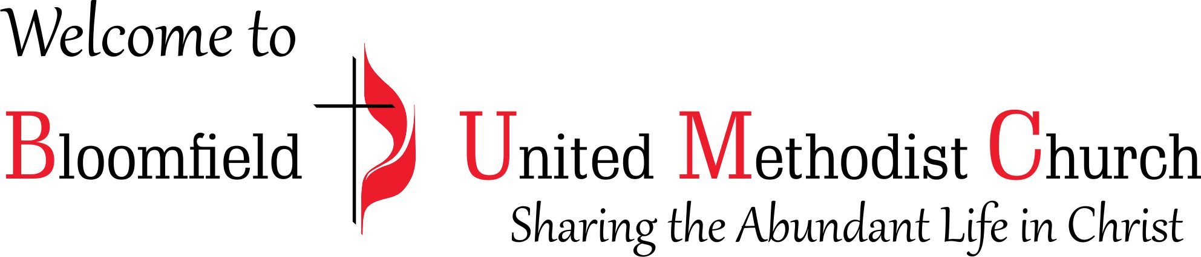

4th Sunday after the Epiphany

January 28, 2024
11:00am

