CALL TO WORSHIP
L: Lenten travelers, when you feel the security of God’s love, affirmation of God’s call, and covered in God’s grace… P: God comes near.
L: When you feel deserted and alone, starving and parched for a caring hand or an encouraging word, troubled and uncertain as the ground under you shifts like sand…
P: God comes near. L: When you feel emboldened to act, inspired to speak, energized to live as bearers of the good news that the Kingdom of God is here… P: God comes near. L: In all seasons of our lives, God comes near to us and does not forsake us. ALL: We gather to come near to God whose ever-present love remains near no matter where our journey takes us. Amen.
OPENING HYMN “Come Thou Almighty King“ UMH 61

PASTORAL PRAYER

OPENING PRAYER: The season of Lent is here again and, as with so many times before, we find that we are not really ready for this journey of discipleship. So many things claim our lives and prevent us from being ready to take the steps in faith. As we look at our barrier of readiness, help us to remember that Christ is with us, every step of the way. We are not alone. Christ will help lift our hearts and spirits and direct our paths. Enable us, loving Savior, to take this journey of faith to new life with you. Amen.

WELCOME

PSALTER Psalm 25: 1-10 UMH 756

BLACK HISTORY MOMENT

1st READING Genesis 9: 8-17

SHARINGS, JOYS, CONCERNS & PRAYERS OF THE PEOPLE

MUSIC MINISTRY BUMC Bell Choir

GOSPEL READING Mark 1: 9-15

PRAISE And WORSHIP
“He Is Exalted” TFWS 2070
“Jesus Walked This Lonesome Valley” TFWS 2112
“Holy Ground” TFWS 2272

SERMON Pastor Egan Bovell

PRAYER OF DISCIPLESHIP

TITHES & OFFERING UMH 95

NOTICES AND ANNOUNCEMENTS

CLOSING HYMN “Precious Name” UMH 536

BENEDICTION
PRAYER LINE – Tuesdays at 6:30am
Phone #: 848 220 3300 / Conference ID #: 5203248

ZOOM BIBLE STUDY – Wednesdays at 7:00pm
Meeting ID: 873 3085 4771 / Passcode: 810341

The Cooperative Parish Black History Month Service will be today Sunday, February 18, 2024 at 4:00pm at North United Methodist Church (1205 Albany Avenue, Hartford). All are welcome to attend.

PRAYER LIST: Brenda Ifill, Cheryl Pringle, Ron Dixon, Carmen Edith Morris, Billie & Michael Anthony, Liz Donar, Rev. Boliver Valentine, Audrey Nathan, Avril Wallace, Anthony and I-rose Gordon, Molly Williams, Leroy Clemons, Roy Greaves, Demery family, Robert Brown, Ted Baron, Boris, the families of Margaret Leslie, Derek Bruce and all those experiencing the loss of loved ones.

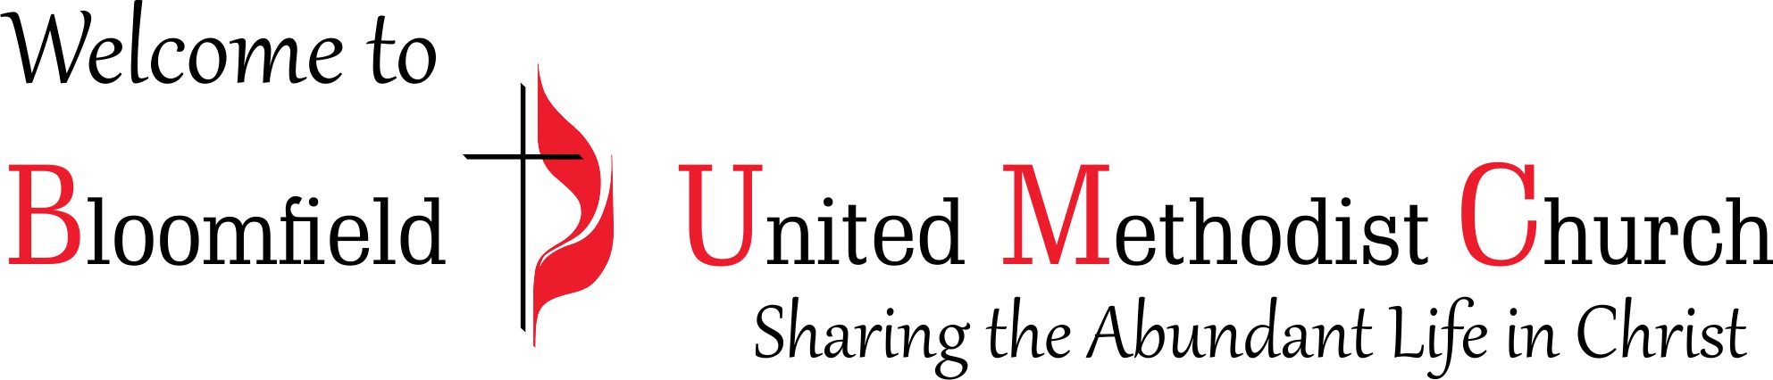

1st Sunday in Lent
Black History Month

February 18, 2024
11:00am

