PRELUDE

CALL TO WORSHIP
L: The mighty one, God the LORD, speaks and summons the earth from the rising of the sun to its setting.
P: Out of Zion, the perfection of beauty, God shines forth
And yet, God’s glory showed up anyway.
L: Sometimes we are like the disciples who witnessed Jesus’ transfiguration and wanted to cling to that one glorious moment.
P: And yet, God called them down from the mountain.
L: So, we gather today, some of us feeling ready and some of us feeling wholly unprepared, yet all are called together to worship and to be led by glory out into the world.
P: God, may we perceive your glory all around us, pointing us in the way you would have us go. Amen.

OPENING HYMN “I Stand Amazed in the Presence” UMH 371

PASTORAL PRAYER

OPENING PRAYER: Almighty God, giver of life, your light shines in our lives and your glory is revealed through your Son, Jesus Christ. Mighty God, stay with us always, not only in our worship, but as we share the risk and challenge of living our faith. By your powerful Spirit, turn our fear to courage. May Your glory shines in the face of Christ; shine in our hearts and lives. May your name be praised, glorious God! Reveal this glory to us as you did to Peter, James, and John, that we may be filled with his power and our mouths may proclaim his presence forevermore. Amen.

WELCOME & GREETINGS
PSALTER Psalm 50: 1-6 UMH 783

1st READING 2 Kings 2: 1-12

SHARINGS, JOYS, CONCERNS & PRAYERS OF THE PEOPLE

PRAYERS OF CONFESSION (Soloist leads)
Soloist: Take my life, and let it be consecrated, Lord, to thee.
All: We are yours, Lord, though we fight for control. Take our lives; make us yours. Soloist: Take my moments and my days; let them flow in ceaseless praise.
All: We are yours, Lord, though our busyness gets in the way. Take our days; make them yours. Soloist: Take my hands and let them move at the impulse of thy love. All: We are yours, Lord, though we are not always in service. Take our hands; make them yours. Solo: Take my feet and let them be swift and beautiful for thee.
All: We are yours, Lord, even though our feet don’t always move with your Spirit. Take our feet; make them yours. Amen.

BLACK HISTORY MOMENT/MUSIC MINISTRY

GOSPEL READING Mark 9: 2-9

PRAISE & WORSHIP
“Shine, Jesus, Shine” TFWS 2173
“Halle, Halle, Hallelujah” TFWS 2026
“All Hail King Jesus” TFWS 2069
SERMONIC HYMN “Your Grace and Mercy” Screen

SERMON Pastor Egan Bovell

PRAYER OF DISCIPLESHIP

TITHES AND OFFERINGS UMH 95
NOTICES AND ANNOUNCEMENTS

CLOSING HYMN “Christ Whose Glory Fills the Skies” UMH 173

PRAYER LINE – Tuesdays at 6:30am
Phone #: 848 220 3300 / Conference ID #: 5203248

ZOOM BIBLE STUDY – Wednesdays at 7:00pm
Meeting ID: 873 3085 4771 / Passcode: 810341

Ash Wednesday Service this Wednesday, February 14, 2024 at 5:00pm.

The Cooperative Parish Black History Month Service will be next Sunday, February 18, 2024 at 4:00pm at North United Methodist Church (1205 Albany Avenue, Hartford). All are welcome to attend.

PRAYER LIST: Brenda Ifill, Cheryl Pringle, Ron Dixon, Carmen Edith Morris, Billie & Michael Anthony, Liz Donar, Rev. Boliver Valentine, Audrey Nathan, Avril Wallace, Anthony and I-rose Gordon, Molly Williams, Leroy Clemons, Roy Greaves, Demery family, Robert Brown, Ted Baron, Boris, the families of Margaret Leslie, Derek Bruce and all those experiencing the loss of loved ones.

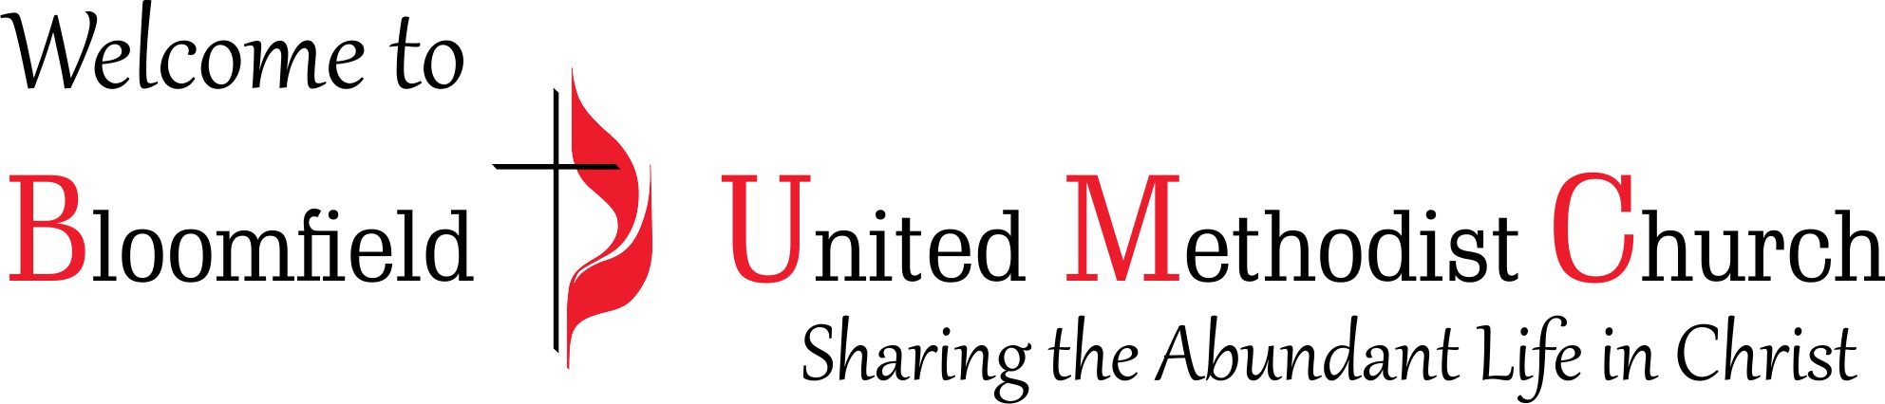

Transfiguration Sunday
Black History Month

February 11, 2024
11:00am

