CALL TO WORSHIP:
L: Come, faithful watchers, and behold, your salvation is here!
P: We greet the Wondrous Light, our Messiah, Christ the Lord.
L: We have waited and watched, longing for God to show up and save us from the suffering and pain in our world.
P: We greet the Wondrous Light, the fulfillment of our shocking hope.
L: We have waited and watched, longing for peace to reign among us, a peace that removes unjust barriers, frees us from sin, and binds us together as neighbors, family, and friends.
P: We greet the Wondrous Light, the bringer of our just peace.
L: We have waited and watched, longing for joy that is persistent in the face of the grief, lament, chaos, and oppression that weigh on us day in and day out.
P: We greet the Wondrous Light, the source of our fierce joy.
L: We have waited and watched, longing to encounter the love that transforms us, the Love that is now here among us, first as a babe in a manger, then as a teacher, a friend, and our Savior.
P: We greet the Wondrous Light, Love Incarnate who has come to save us and transform us. Amen.

OPENING HYMN “O Come, All Ye Faithful” vs. 1-4, 6 UMH 234

PASTORAL PRAYER

OPENING PRAYER: Emmanuel, God-with-us most of all tonight, your light lifts up our hearts, our spirits, and our voices. We give you thanks for your birth long ago and presence with us always. Your hope is more trustworthy than our promises. Your peace is deeper than our prayers. Your joy teaches us to sing even when we want to cry. Your love is wider than the chorus of the galaxies, and yet your Star shines on us now in this church which has become a manger. Amen.
PSALTER Canticle of Mary UMH 199

LIGHTING OF THE FOURTH ADVENT CANDLE
“Light the Advent Candle” Verse 4 TFWS 2090

1st READING 2 Samuel 7: 1-11,16

TIME WITH THE CHILDREN

SHARINGS, JOYS, CONCERNS & PRAYERS OF THE PEOPLE

PRAYER OF CONFESSION: God of Light, we confess that we have gone astray and have left Your light. We follow the dim lights of the world of success and fortune. We follow the dim lights that call us to be more religious by following rules. We follow the fading light of personal salvation. Forgive us for not seeking the true Light of Your love for all the world. Forgive us for not following the ways of Jesus, who commanded us to love one another. Call us to be light-bearers of love, compassion, and justice, in which the mystery of Your love is revealed. In the name of Jesus the Messiah, we pray. Amen.

MUSIC MINISTRY BUMC Youth Bell Choir

GOSPEL READING Luke 1: 26-38

PRAISE AND WORSHIP
“Lord, I Lift Your Name on High” TFWS 2088
“Days of Elijah” Screen
“His Name is Wonderful” UMH 174

SERMONIC HYMN “Jesus, the Light of the World” Screen

SERMON Pastor Egan Bovell

MUSIC MINITRY BUMC Youth Bell Choir
PRAYER OF DISCIPLESHIP

TITHES AND OFFERING

NOTICES & ANNOUNCEMENTS

CLOSING HYMN “Joy to the World” UMH 246

BENEDICTION
PRAYER LINE – Tuesdays at 6:30am
Phone #: 848 220 3300 / Conference ID #: 5203248

ZOOM BIBLE STUDY – Wednesdays at 7:00pm
Meeting ID: 873 3085 4771 / Passcode: 810341

Zoom Watchnight Service, Sunday, December 31 at 10:30pm. The Zoom Bible Study link will be used.

PRAYER LIST: Ron Dixon, Carmen Edith Morris, Billie & Michael Anthony, Liz Donar, Rev. Boliver Valentine, Audrey Nathan, Avril Wallace, Anthony and I-rose Gordon, Molly Williams, Leroy Clemons, Roy Greaves, Demery family, Robert Brown, Ted Baron, Boris, the families of Margaret Leslie, Derek Bruce and all those experiencing the loss of loved ones.

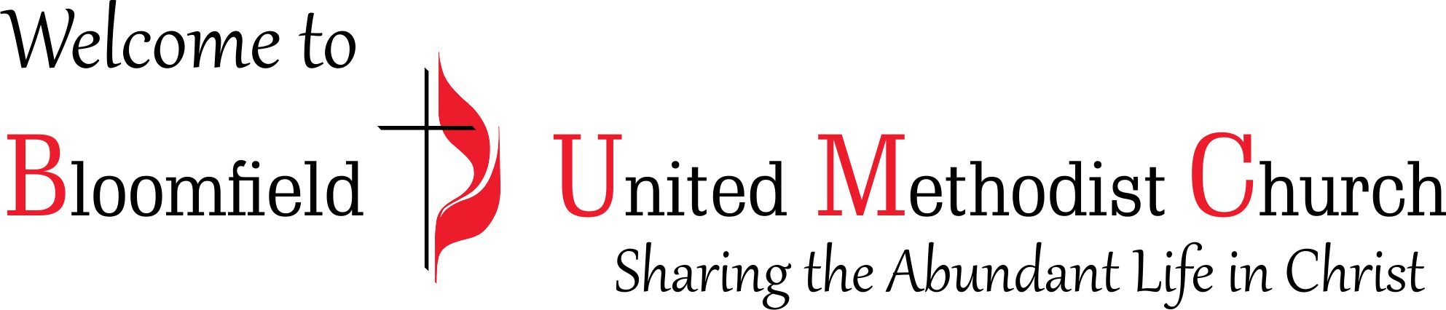

4th Sunday of Advent
Christmas Eve
December 24, 2023
11:00am

