PRELUDE (let us quiet our hearts before the Lord)
Welcome to BUMC! Our church family is delighted that you have joined us to worship today! We pray that you will be blessed by our worship service. We invite those who are not members to consider membership. Please speak with the Pastor or Lay Leader.

CALL TO WORSHIP:
L: Give thanks to the Lord.
P: Call upon God’s holy name.
L: Sing praises to our God.
P: Tell of God’s wonderful works.
L: The Lord offers bread from heaven to satisfy our hunger.
P: God issues water from the solid rock to quench our thirst.
L: Give thanks to the Lord.
ALL: Let everything that draws breath praise God. Amen.

OPENING HYMN “Glorious Things of Thee Are Spoken” UMH 731

OPENING PRAYER: Lord, who lifts us up, resides in our hearts today. Help us to listen closely for your word to us. Remind us that you are always with us, throughout all of our lives. Give us confidence in your presence, so that we may go into your world ready to witness to your love through our works and our deeds, for we pray these things in Jesus’ name. Amen.

WELCOME & GREETINGS

PSALTER Psalm 105 UMH 828

1st READING Exodus 16: 2-15
L: This is the Word of God
P: For the People of God

SHARINGS, JOYS, CONCERNS & PRAYERS OF THE PEOPLE

PRAYER OF CONFESSION: You know how fickle we are, O Lord. We proclaim your presence with us and then we behave in ways which run counter from your word. We get caught up in our own needs and whine about the injustices we feel in our lives. Help us to place our trust in your mercy and your compassionate love. Forgive us when we stray from your ways and wander into paths of self-pity and self-destruction. Lift us from the deep morass and put us back on track. Give us confidence in your presence and your direction throughout our lives, for we ask these things in Jesus’ name. Amen.
MUSICAL OFFERING

GOSPEL READING Matthew 20: 1-16
L: This is the Word of God
P: For the People of God

PRAISE AND WORSHIP
“I’m Gonna Live So God Can Use Me” TFWS 2153
“Someone Asked the Question” TFWS 2144
“Sanctuary” TFWS 2164

SERMON Pastor Egan Bovell

GIDEONS INTERNATIONAL REPORT

PRAYER OF DISCIPLESHIP

TITHES AND OFFERING

DOXOLOGY

NOTICES & ANNOUNCEMENTS

CLOSING HYMN “Take Up Thy Cross “ UMH 415

BENEDICTION

Our Mission Statement

The Bloomfield United Methodist Church’s mission is to be an instrument of God’s purpose in the world by coming together as a Christian faith community which is open to all ages and races; promoting spiritual growth and Christian ideals in daily living; providing opportunity for worship; nurturing and caring for one another; educating our children so they will know God; and reaching out to, and welcoming in the community and the world.

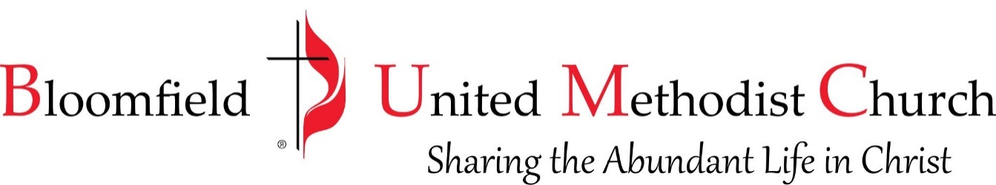

17th Sunday after Pentecost
September 24, 2023
11:00am
