CALL TO WORSHIP
L: God is in God’s holy temple. Be ready to greet the Redeemer.
P: Stand up and bless the Lord, ye people of his choice; stand up and bless the Lord your God with heart and soul and voice.
L: God is with us and call us to this holy hour.
P: We come rejoicing and praising God.
L: This day let service to God be your choice.
P: God is our strength and song, and his salvation ours; then be his love in Christ proclaimed with all our ransomed powers.
L: Are you ready to worship?
P: We believe that we are.
L: Put away all those cares and worries that keep you from hearing God’s word.
P: The cares and worries of the world have been put aside that we may be truly ready.
L: The Lord comes to you this day.
P: Thanks be to God for God’s abiding presence and promise. Amen.

OPENING HYMN “Stand up and Bless the Lord” UMH 662

PASTORAL PRAYER

OPENING PRAYER (in unison): Through the week of stress and demands, we come to you this day, O Lord. Awaken us again to your comforting and loving presence in our lives. Help us to be open to the many ways in which you have called to us and sustained us. Make us ready to be of service to you. Amen.

WELCOME & GREETINGS
PSALTER Psalm 78: 1-16 UMH 799
1st READING Joshua 24: 1-3a, 14-25

CELEBRATIONS, CONCERNS & PRAYERS OF THE PEOPLE

PRAYER OF CONFESSION (in unison): O Lord there never seems to be enough time to do all the things that are demanded of us. Schedules become crowded. We live by the clock. We think we are ready for all events that will come our way. But we are rarely ready for you. We would like you to come to us at the planned time so that we can fit you into our busy lives. Forgive us, Lord, for trying to make you a scheduled event. We have moved you to a time on our weekly calendars. Yet you are the eternal God who has always loved us and been ready to receive us. Help us to learn that, with you as our foundation, we can handle anything that comes our way. With you as our focus, all things pale in comparison. Let us look at the priorities in our lives and see where we have placed service to you. Amen.

2nd READING 1 Thessalonians 4: 13-18

MUSIC MINISTRY

GOSPEL READING Matthew 25: 1-13

PRAISE AND WORSHIP
“Guide My Feet” TFWS 2208
“We Bring the Sacrifice of Praise” TFWS 2031
“Holy Ground” TFWS 2272

SERMONIC HYMN “A Charge to Keep I Have“ UMH 413

SERMON Pastor Egan Bovell

PRAYER OF DISCIPLESHIP
TITHES AND OFFERING

NOTICES & ANNOUNCEMENTS

CLOSING HYMN “O Master, Let Me Walk with Thee“ UMH 430

BENEDICTION
PRAYER LINE – Tuesdays at 6:30am
Phone #: 848 220 3300 / Conference ID #: 5203248

ZOOM BIBLE STUDY – Wednesdays at 7:00pm
Meeting ID: 873 3085 4771 / Passcode: 810341

North UMC has invited us to join them for a Festival of Hymns on Sunday, November 12 at 4:00 pm (1205 Albany Avenue, Hartford).

Any member or friend who is interested in learning more about mental health resources or how the faith community can become more aware, you are invited to take a flyer from the table in the lobby. Should you have any questions, feel free to speak to the Pastor.

PRAYER LIST: Billie & Michael Anthony, Liz Donar, Rev. Boliver Valentine, Audrey Nathan, Avril Wallace, Anthony and I-rose Gordon, Molly Williams, Leroy Clemons, Roy Greaves, Demery family, Robert Brown, Ted Baron, Boris, the families of Margaret Leslie, Derek Bruce and all those experiencing the loss of loved ones.

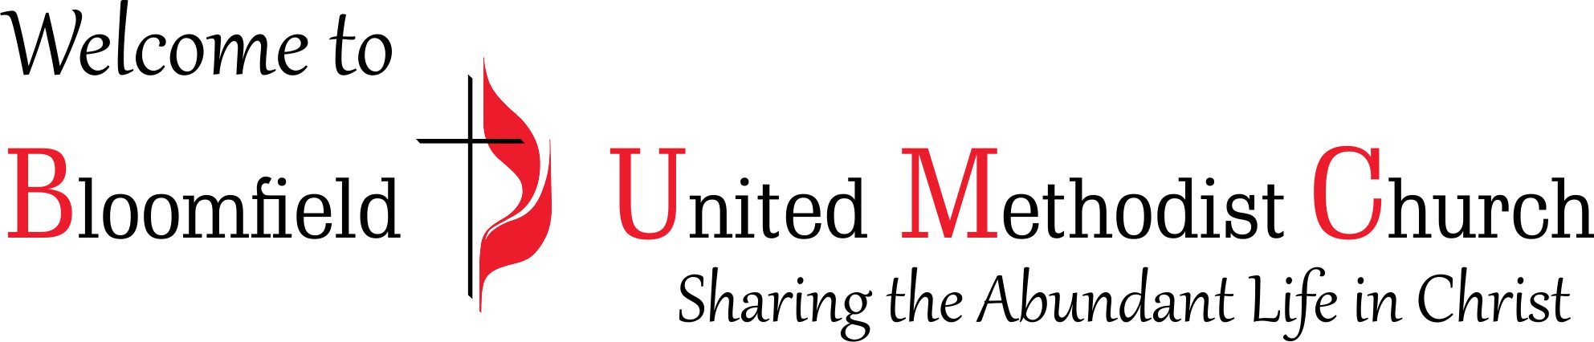

24th Sunday after Pentecost
November 12, 2023
11:00am

