CALL TO WORSHIP
L: We have welcomed the Christ child and declared the glory of God’s salvation that comes to live among us. And yet, still, we wait.
P: We watch and work for God’s kin-dom on earth as it is in heaven.
L: We prepare to welcome a new year, thankful for how God has brought us through the past year and anxious to discover what the new year might bring.
P: We watch and work for God’s kin-dom on earth as it is in heaven.
L: We join generations of Simeons and Annas who learned and taught us how to listen, notice, and discern divine love at work in the world.
P: We watch and work for God’s kin-dom on earth as it is in heaven.
L: Come, let us worship God, whose love endures from generation to generation, guiding us from one year to the next.
P: Come, let us worship as we live in anticipation of God’s kin-dom on earth as it is heaven. Amen.

OPENING HYMN “Once in Royal David’s City” UMH 250

PASTORAL PRAYER

OPENING PRAYER: Almighty creator, we come to shout and rejoice in the wonderful gift of your son for our world. It is a miracle that fills our lives with your glory. On this last day of the year, may our celebration honor the good we have received from your hand, even as we look forward to walking faithfully with you in the new year ahead .As those who came before us, we will not be silent in our love for you :we will not mute our pure joy for what you have brought to our lives. Amen.

WELCOME & GREETINGS

PSALTER Psalm 148 UMH 861

SHARINGS, JOYS, CONCERNS & PRAYERS OF THE PEOPLE

PRAYER OF CONFESSION
L: Friends, let us prepare to enter the new year with hearts that have been unburdened, and let us make our confession before God and one another, first in silent prayer. (pray in silence)
P: God of stars and angels, God of sheep and lambs, God of abundance and grace: You know us well, better than we know ourselves. You hear us cry “Gloria!” and “Praise!” And you watch us tear things apart with our words and deeds. You hear us say “Thy will be done” and “Use me, O God” And you watch us do nothing in response to cries for help. You know us, and you love us, and you forgive. Hear us now say, “Help us to change; turn us around, make us more loving and courageous and hopeful.” This we pray in Jesus’ name. Amen.

TIME WITH THE CHILDREN

1st READING Isaiah 61: 1-10 - 62: 3

MUSICAL INTERLUDE

2ND READING Galatians 4: 4-7

PRAISE AND WORSHIP
“Halle, Halle, Halle” TFWS 2026
“As the Deer” TFWS 2025
“What a Mighty God We Serve” TFWS 2021

GOSPEL READING Luke 2: 22-40

SERMON Pastor Egan Bovell

PRAYER OF DISCIPLISHIP

TITHES AND OFFERINGS

DOXOLOGY UMH 95

OFFERTORY PRAYER

NOTICES & ANNOUNCEMENTS

CLOSING HYMN “Go Tell it on the Mountain” UMH 251

BENEDICTION
PRAYER LINE – Tuesdays at 6:30am
Phone #: 848 220 3300 / Conference ID #: 5203248

ZOOM BIBLE STUDY – Wednesdays at 7:00pm
Meeting ID: 873 3085 4771 / Passcode: 810341

Zoom Watchnight Service, Sunday, December 31 at 10:30pm. The Zoom Bible Study link will be used.

PRAYER LIST: Ron Dixon, Carmen Edith Morris, Billie & Michael Anthony, Liz Donar, Rev. Boliver Valentine, Audrey Nathan, Avril Wallace, Anthony and I-rose Gordon, Molly Williams, Leroy Clemons, Roy Greaves, Demery family, Robert Brown, Ted Baron, Boris, the families of Margaret Leslie, Derek Bruce and all those experiencing the loss of loved ones.

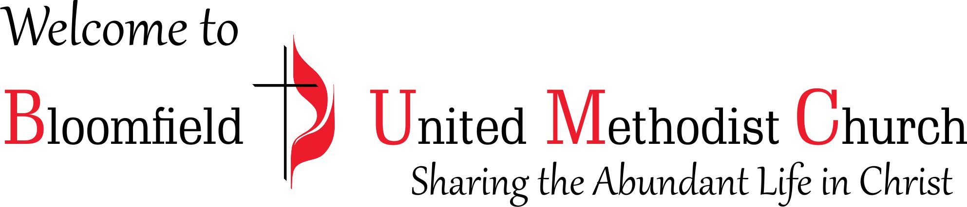

1st Sunday after Christmas
December 31, 2023
11:00am

