CALL TO WORSHIP:
L: Love has come down to us this Advent Season.
P: Divine love which heals and transforms our lives.
L: With great joy, we receive that love and share it with others.
P: We open our hearts to all God’s children, the last, the least, and the lost, as well as those who feel privileged.
L: The Lord has done and continues to do great things for us.
P: Praise be to God who loves us so much and who challenges us to be people of joy in this darkened world. Amen.

OPENING HYMN “Hark! the Herald Angels Sing” UMH 240

PASTORAL PRAYER

OPENING PRAYER: Lord God, as we gather this day, we open our hearts to you, seeking your healing and transforming love. Our world cries for justice for all people, yet the leaders seem intent on bantering with one another, unmindful of the peace-bringers and those who would heal and teach the ways of peace. Be with all of us. Prepare us for this bright light of love which you are sending to us, for we ask this in Jesus’ Name. Amen.

WELCOME & GREETINGS
PSALTER Psalm 126 UMH 847

LIGHTING OF THE THIRD ADVENT CANDLE
“Light the Advent Candle” verse 3 TFWS 2090

^{1st} READING Isaiah 61: 1-4, 8-11

JOYS, CONCERNS & PRAYERS OF THE PEOPLE

PRAYER OF CONFESSION: God, you know how we want to be people of peace and justice, but when opportunities come to participate in groups working for justice, we turn our backs and walk the other way, or we give a token pledge and then ignore further pleas for assistance. We hide our names from appearing on roles of supporters of justice-seeking organizations. Forgive us, O God, when we give only lip service to ministries of justice rather than pledging our lives to helping all people in need. Free us from our selfishness. Banish our fears and move us in ways of peace and justice, bringing your love and hope to all God’s children. We ask these things Patient and forgiving in God’s name. Amen.

MUSIC MINISTRY

GOSPEL READING John 1: 6-8, 19-28

PRAISE AND WORSHIP
“This Is the Day” UMH 657
“Jesus Name Above All Names” TFWS 2071
“How Great is Our God” Screen

SERMONIC HYMN “Come Thou Long-Expected Jesus” UMH 196

SERMON “Can I Get a Witness?” Pastor Egan Bovell
PRAYER OF DISCIPLESHIP

TITHES AND OFFERING

NOTICES & ANNOUNCEMENTS

CLOSING HYMN “O, Zion Haste” UMH 570

BENEDICTION
PRAYER LINE – Tuesdays at 6:30am
Phone #: 848 220 3300 / Conference ID #: 5203248

ZOOM BIBLE STUDY – Wednesdays at 7:00pm
Meeting ID: 873 3085 4771 / Passcode: 810341

Join us in the fellowship hall after today’s worship service for Tea with Pastor Egan and Felicia.

Order your poinsettia in memory or in honor of a loved one. Poinsettias are $15 each and orders are due to Saleena by Wednesday, December 20.

There will be a Children & Youth Christmas Celebration at the church on Saturday, December 23rd at 3:00pm.

Any member or friend who is interested in learning more about mental health resources or how the faith community can become more aware, you are invited to take a flyer from the table in the lobby. Should you have any questions, feel free to speak to the Pastor.

PRAYER LIST: Billie & Michael Anthony, Liz Donar, Rev. Boliver Valentine, Audrey Nathan, Avril Wallace, Anthony and I-rose Gordon, Molly Williams, Leroy Clemons, Roy Greaves, Demery family, Robert Brown, Ted Baron, Boris, the families of Margaret Leslie, Derek Bruce and all those experiencing the loss of loved ones.

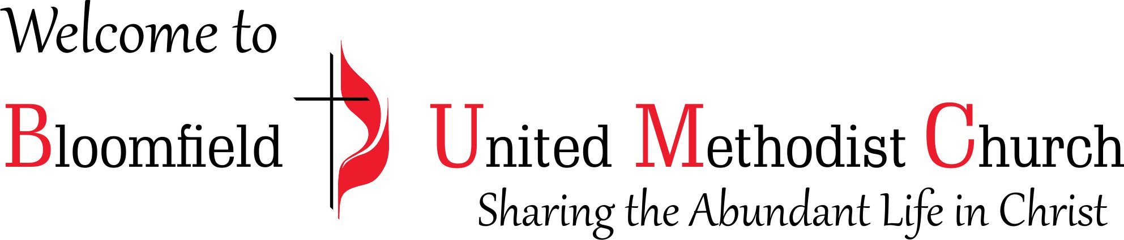

3rd Sunday of Advent
December 17, 2023
11:00am

