CALL TO WORSHIP:
L: In the middle of dark times, our Lord cries out:
P: “Comfort, comfort my people!”
L: When it seems as though we cannot see the light at the end of the tunnel,
P: Our Lord says to us, “ Be at peace, for your time of difficulty has ended.”
L: Lord, we await the time of comfort and peace!
P: Lord, we are thankful for your compassion and never-failing love for us.
L: Lord, open our hearts to receive this good news!
P: Prepare us to be people of great faith and compassion as we look forward to this wondrous event you have proclaimed to us. Amen.

OPENING HYMN “O Come, O Come Emmanuel” UMH 211

PASTORAL PRAYER

OPENING PRAYER: Lord, in the midst of our busy time, when we are in the rush to Christmas, you burst into our lives with the tantalizing promise of something new. Open our hearts and spirits to the glorious possibilities of hope and peace to come. Help us to prepare our lives to receive you. We thank you for all the blessings you pour on us and for the privilege we have in sharing these blessings with others. Be with us all this day and all these days that we may serve you better by helping others in need. In Jesus’ Name, we pray. Amen.

WELCOME & GREETINGS
PSALTER Psalm 85 UMH 806

LIGHTING OF THE SECOND ADVENT CANDLE
“Light the Advent Candle” TFWS 2090

PRAYER OF CONFESSION: Into the dark depths of our fear and anguish, you, O Lord, reach out to us. We need your guidance today, for we have found it far too easy to stray into selfish pathways. We seek first our own comfort; we gather our toys and trinkets and proclaim that all is right with the world, yet our hearts feel strangely discomforted. Guide us and gather us, Lord. Teach us again to be people of peace and hope. Help us to cast off the mantle of greed and hatred. Forgive us for the many times when we have ignored the cries of those in need; when we have turned our backs on opportunities to help others. Forgive us, Lord. Touch our hearts and bring your bright light of salvation to them that we might turn again to you and in your love may be part of the ministries of peace and justice. Help us again to hear the voice of one who cries in the wilderness, “Prepare the way of the Lord. Make straight in the desert a highway for our God.” In the name of Jesus Christ, our Savior, we offer this prayer. Amen.

^{1st} READING Isaiah 40: 1-11

JOYS, CONCERNS & PRAYERS OF THE PEOPLE

MUSIC INTERLUDE

GOSPEL READING Mark 1: 1-8

PRAISE AND WORSHIP
“All Hail King Jesus” TFWS 2069
“I Love You Lord” TFWS 2068
“Emmanuel” UMH 204

SERMON “When Righteousness and Peace Kissed”
Pastor Egan Bovell
PRAYER OF DISCIPLESHIP

TITHES & OFFERING

NOTICES & ANNOUNCEMENTS

CLOSING HYMN “Lift Up Your Heads” UMH 213

BENEDICTION
PRAYER LINE – Tuesdays at 6:30am
Phone #: 848 220 3300 / Conference ID #: 5203248

ZOOM BIBLE STUDY – Wednesdays at 7:00pm
Meeting ID: 873 3085 4771 / Passcode: 810341

BUMC is invited to Metropolitan AME Zion Church (2051 Main Street, Hartford) for their Service of Lessons and Carols on Saturday, December 16th at 2pm. The BUMC Youth Bell Choir will be part of the program.

Any member or friend who is interested in learning more about mental health resources or how the faith community can become more aware, you are invited to take a flyer from the table in the lobby. Should you have any questions, feel free to speak to the Pastor.

PRAYER LIST: Billie & Michael Anthony, Liz Donar, Rev. Boliver Valentine, Audrey Nathan, Avril Wallace, Anthony and I-rose Gordon, Molly Williams, Leroy Clemons, Roy Greaves, Demery family, Robert Brown, Ted Baron, Boris, the families of Margaret Leslie, Derek Bruce and all those experiencing the loss of loved ones.

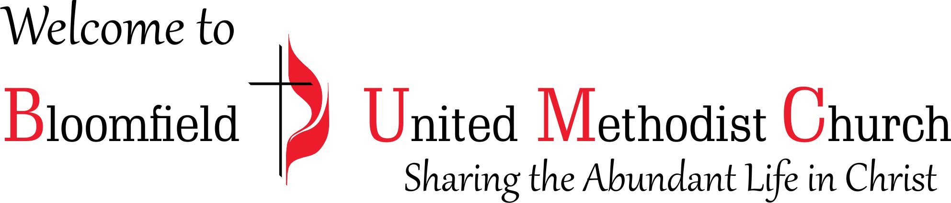

2nd Sunday of Advent
December 10, 2023
11:00am

